ADD YOUR COMPLETE SYSTEM TITLE HERE IN
ININVERTED PYRAMID - USE CAPSLOCK

A Project Documentation
Presented to
the Faculty of Information Technology
Saint Louis College
City of San Fernando, La Union

In Partial Fulfillment
of the Requirements for the Course
IT 121 – Advanced Database Systems

by:
FIRSTNAME MI. LASTNAME
FIRSTNAME MI. LASTNAME
FIRSTNAME MI. LASTNAME
FIRSTNAME MI. LASTNAME
FIRSTNAME MI. LASTNAME

Project Description
Using your Use Case Diagram as a blueprint, explain the project’s functionality in paragraph form. Break down the logic by user type, detailing exactly how each individual interacts with the system to achieve their goals. Ensure the narrative clearly illustrates the end-to-end journey for every actor involved.

Use Case Diagram

Entity Relationship Diagram
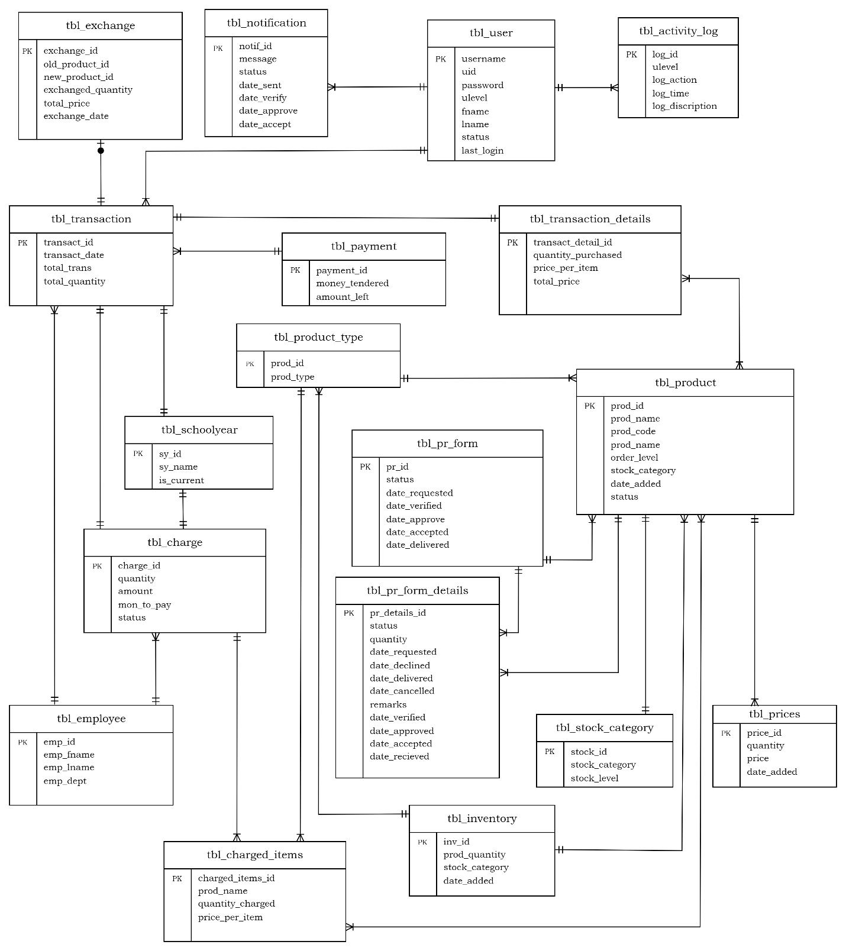

Relational Database Schema
tbl_user {uid, username, password, ulevel, fname, lname, status, last_login}
tbl_transaction {transact_id, transact_date, total_trans, total_quantity, emp_id, payment_id, sy_id}
tbl_transaction_details_on_tbl_product {transact_detail_id, prod_id}
tbl_payment {payment_id, money_tendered, amount_left}
tbl_inventory {inv_id, prod_quantity, stock_category, date_added, prod_id, prodt_id}
tbl_employee {emp_id, emp_fname, emp_lname, emp_dept}
tbl_pr_form {pr_id, status, date_requested, date_verified, date_approved, date_accepted, date_delivered}
tbl_pr_form_details {pr_details_id, status, quantity, date_requested, date_declined, date_delivered, date_cancelled, remarks, prod_id, pr_id}
tbl_product_type {prodt_id, prod_type}
tbl_product {prod_id, prod_name, prod_code, prod_price, order_level, stock_category, date_added, status, prodt_id, stock_id}
tbl_stock_category {stock_id, stock_category, stock_level}
tbl_notification {notif_id, message, status, date_sent, date_verify, date_approve, date_accept}
tbl_prices {price_id, quantity, price, date_added, prod_id}
tbl_schoolyear {sy_id, sy_name, is_current}
tbl_charges {charge_id, quantity, amount, mon_to_pay, status, transact_id, sy_id, emp_id}
tbl_charged_items {charged_items_id, prod_name, quantity_charged, price_per_item, charge_id, prodt_id, prod_id}
tbl_activity_log {log_id, ulevel, log_action, log_time, log_description}
tbl_exchange {exchange_id, old_product_id, new_product_id, exchanged_quantity, total_price, exchange_date, transact_id}

Logical Data Structure
Field Name | Data Type
Uid | int
username | varchar
password | varchar
Ulevel | varchar
Fname | varchar
Lname | varchar
Status | varchar
last_login | datetime
tbl_user

tbl_product_type
Field Name | Data Type
prodt_id | int
prod_type | varchar

tbl_stock_category
Field Name | Data Type
stock_id | int
stock_category | varchar
stock_level | int

tbl_product
Field Name | Data Type
prod_id | int
prodt_id | int
stock_id | int
prod_code | int
prod_name | varchar
order_level | int
stock_category | varchar
date_added | datetime
status | varchar

tbl_inventory
Field Name | Data Type
inv_id | int
prod_id | int
prodt_id | int
prod_quantity | int
stock_category | varchar
date_added | datetime

tbl_pr_form
Field Name | Data Type
pr_id | int
status | varchar
date_requested | datetime
date_verified | datetime
date_approved | datetime
date_accepted | datetime
date_delivered | datetime

tbl_pr_form_details
Field Name | Data Type
pr_details_id | int
pr_id | int
prod_id | int
status | varchar
quantity | int
date_requested | datetime
date_declined | datetime
date_delivered | datetime
date_cancelled | datetime
remarks | varchar

tbl_transaction_details
Field Name | Data Type
transact_detail_id | int
transact_id | int
prodt_id | int
prod_id | int
quantity_purchased | int
price_per_item | decimal
total_price | decimal

tbl_transaction
Field Name | Data Type
transact_id | int
cust_id | int
transact_date | date
payment_id | int
total_trans | decimal
total_quality | int
school_year | int

tbl_payment
Field Name | Data Type
payment_id | int
money_tendered | decimal
amount_left | decimal

tbl_employee
Field Name | Data Type
cust_id | int
emp_id | int
cust_fname | varchar
cust_lname | varchar
emp_dept | varchar

tbl_schoolyear
Field Name | Data Type
sy_id | int
sy_name | varchar
is_current | tinyint

tbl_prices
Field Name | Data Type
price_id | int
prod_id | int
quantity | int
price | decimal
date_added | datetime

tbl_notification
Field Name | Data Type
notif_id | int
message | varchar
status | enum
date_sent | datetime
date_verify | datetime
date_approve | datetime
date_accept | datetime

tbl_charges
Field Name | Data Type
charge_id | int
transact_id | int
employee_id | int
quantity | int
amount | decimal
mon_to_pay | int
status | varchar
school_year | int

tbl_charged_items
Field Name | Data Type
charged_items_id | int
charge_id | int
prodt_id | int
prod_id | int
prod_name | varchar
quantity_charged | int
price_per_item | decimal

tbl_exchange
Field Name | Data Type
exchange_id | int
transact_id | int
old_product_id | int
new_product_id | int
exchanged_quantity | int
total_price | decimal
exchange_date | datetime

tbl_activity_log
Field Name | Data Type
log_id | int
ulevel | varchar
log_action | enum
log_time | timestamp
log_description | text

